ELECENG 3EJ4
Lab Report #3
Instructor: Dr. Chen
Jasmine Dosanjh – dosanj5 – 400531879
November 2, 2025

Part 1 Questions

Q1. (15 Points)
(1) Below are the plots for the simulated and measured $V_{o}$vs $V_{sig}$ characteristics obtained in Steps 1.2 and 1.6:
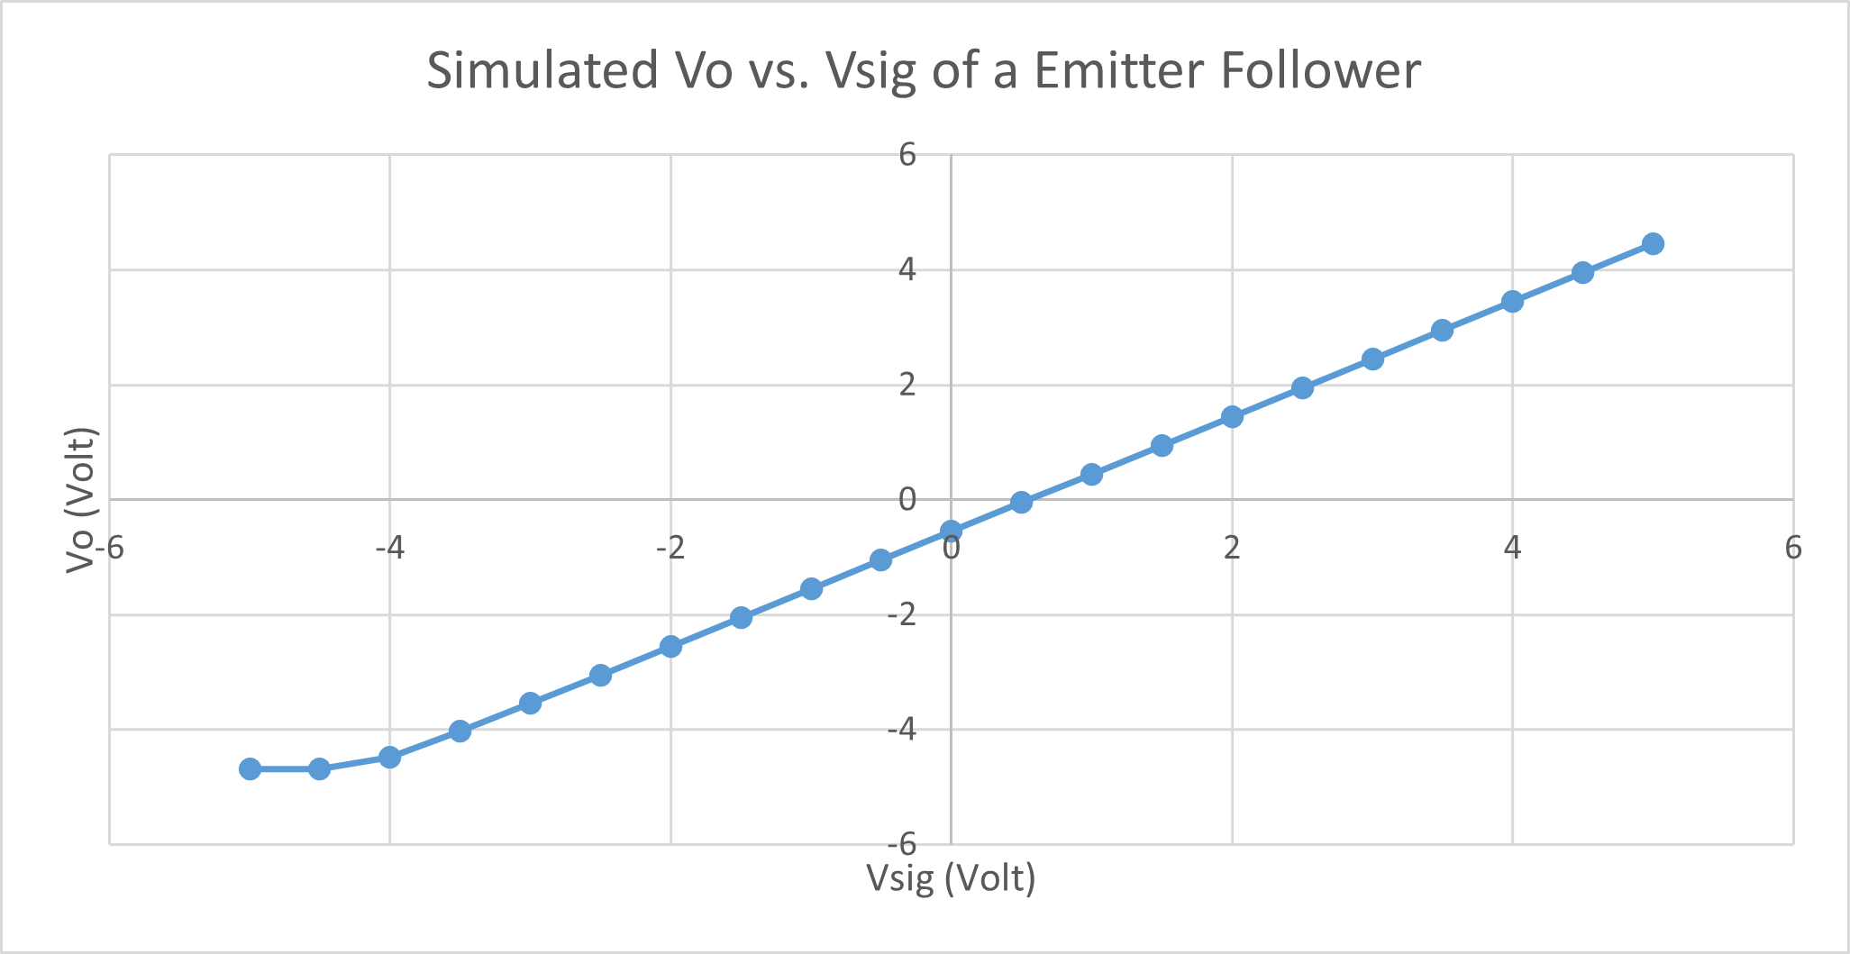  Figure 1. Simulated Data Step 1.2 | 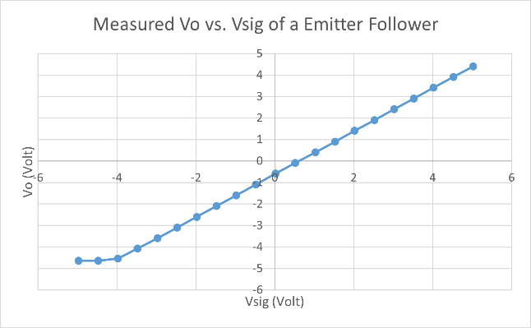  Figure 2. Measured Data Step 1.6
Both graphs are very similar, as they share the same overall shape:
Let’s explain this by examining the following equation:
$$V_{BE}=V_{B}-V_{E}=V_{sig}-V_{o}$$
- For the first two points of both graphs, the slope is flat because for $V_{sig}≤-4.5V$, $V_{o}$ does not change. This implies that $V_{BE}<0.7 V$, and the BJT is in cutoff.
- Once $V_{o}$ increases linearly with $V_{sig}$, $V_{BE}>0.7V$ and the transistor enters the active region,
Figure 3. Simulated Data Step 1.2
(2) The DC input range for $V_{sig}$ is $-5V≤V_{sig}≤5V$, but as mentioned in (1) $V_{o}$ is flat for $V_{sig}≤-4.5V$. This means that the circuit does not work as a common collector in this region as the gain $\frac{V_{o}}{V_{sig}}=0≠1.$
Thus, the DC input range for $V_{sig}$ occurs where the BJT is in the active region, and that is $-4.5V≤V_{sig}≤5V$ which corresponds to $V_{o}≈\left[-4.5, 4.5\right] V$.
(3) According to the simulated data from Step 1.2 (refer to Figure 3), the $V_{sig}$ value that results in $V_{o}≈0 V$ is 0.5 V.

Q2. (10 Points)
Based on the simulation and measurement data obtained in Steps 1.3 and 1.8, the intrinsic voltage gain $A_{vo}$ (magnitude and phase) at low frequency (100 Hz) is:
Step 1.3: $\left|A_{vo}\right|=0 dB ∠-8.47×{10}^{-5}°$
Step 1.8: $\left|A_{vo}\right|=0.8 dB$
Figure 4. Simulated Data Step 1.3
Figure 5. Measured Data Step 1.8

Part 2 Questions

Q3. (15 Points)
(1) Based on section 8.2.4 in the textbook, the relationship to express the mirror’s output current $I_{o}$ as a function of $I_{REF}$ is given by:
$$\frac{I_{o}}{I_{REF}}=\frac{Area of EBJ of{ Q}_{2}}{Area of EBJ of Q_{1}}$$
For the schematic in Fig. 3, Q1 and Q2 are the same transistors (2N3906), thus the areas will be the same. This implies that $I_{o}=I_{REF}$.
Figure 6. Simulated Data Step 2.2
(2) Based on the simulation data obtained in Step 2.2,
At $I_{REF}=0.1 mA$, $I_{o}=0.000104 A ⇒I_{o}=1.04I_{REF}$.
At $I_{REF}=1 mA$, $I_{o}=0.000975 A⇒I_{o}=0.975I_{REF}$.
(3) To generate the theoretical predictions, we know from (1) that: $I_{o}=I_{REF}$. By plugging in the values of $I_{REF}$ from (2),
When $I_{REF}=1 mA$, we should have $I_{o}=1 mA$ but we have $I_{o}=0.975 mA$.
When $I_{REF}=0.1 mA$, we should have $I_{o}=0.1 mA$ but we have $I_{o}=0.104 mA$.
As expected, the theoretical values are very close to the simulated ones, demonstrating almost a 1:1 relationship.
Q4. (15 Points)
Figure 7. Simulated Data Step 2.5
(1) Based on the simulation data in Step 2.5,
Input impedance $R_{in}=389.12 Ω.$
Current Gain of current mirror $A_{i}=1.04 A/A$
(2) Based on the simulation data in Step 2.6,
Output impedance $R_{o}=1.58×{10}^{6} Ω.$
(3) Using the above information, we know that the relation to the h-parameters is:
$R_{in}=h_{11}$, $R_{o}=1/h_{22}$, $A_{i}=h_{21}$
The linear two-port network for the current mirror is shown below:

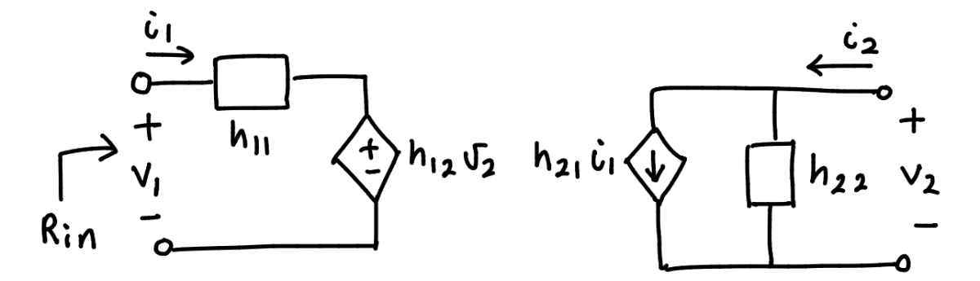
Figure 8. Linear two Port Network
With the following parameters,
$$h_{11}=389.12 Ω$$
$$h_{22}=1.01×{10}^{-4} S$$
$$h_{21}=1.04$$
$h_{12}=7.05×{10}^{-7} @ 100 Hz$ to $1.41×{10}^{-6} @ 200 Hz$
Figure 9. Simulated Data Step 2.6

Part 3 Questions

Q5. (15 Points)
(1) Based on the simulation data in Step 3.2,
Voltage gain $A_{d}=70.07 dB$
(2) In step 3.6, the mismatch voltage calculated was $-1.27×{10}^{-2} V$which was the offset voltage applied to $V_{2}$ in subsequent steps.
(3) In Step 3.8,
Voltage gain $A_{d}=60.3 dB$
This is around 10 dB lower than the simulated value in (1).

Q6. (10 Points)
For low frequency $f_{L}$ of 100 Hz:
Figure 10. Simulation data Step 3.2
- ${Magnitude}_{L}=6.38 V$
- ${Phase}_{L}=-0.518°$
The Upper 3-dB frequency $f_{H}$ is the frequency at which the amplitude becomes $\frac{1}{\sqrt{2}}=0.707$ of its low frequency value, or the phase changes $45°$. This gives us:
Figure 11. Simulation data Step 3.2
- ${Magnitude}_{H}={Magnitude}_{L}× \frac{1}{\sqrt{2}}=4.51 V$
- $f_{H}=11207 Hz$

Q7. (10 Points)
Comparing the upper 3-dB frequencies of this differential amplifier with a current mirror load, with that from Lab 2 of a differential amplifier using resistive loads…
- Lab 3 Q6: $f_{H}=11207 Hz$, $A_{d}=70.07 dB$
- Lab 2 Q8: $f_{H}=8332821 Hz$, $A_{d}=19.63 dB.$
The Lab 2 frequency is much larger than the one in this Lab. This is due to the Miller Theorem, which tells us that a higher voltage gain leads to a larger Miller capacitance, $C_{m}$, which in turn results in a smaller upper 3-dB frequency. Thus since, $f_{H}∝\frac{1}{ A_{d}}$, the larger gain of 70.07 dB in Lab 3 results in a smaller $f_{H}$, and the opposite is true of the smaller gain of 19.63 dB in Lab 2.

Q8. (10 Points)
Thus, the gain-bandwidth products (GBW) of the differential amplifier with a current mirror load, and Lab 2’s differential amplifier using resistive loads are…
- Lab 3 Q6: $GBW=3.57×{10}^{7} Hz$
Figure 12. Simulation data Step 3.2
- Lab 2 Q8: $GBW=7.95×{10}^{7} Hz$

